**Girl’s Menstruation Project in Khotang**

**Project Update as of January 31, 2024**

**Plan vs accomplishment in summary**

|  |  |  |  |  |
| --- | --- | --- | --- | --- |
| **SN** | **Name of activities** | **planned** | **achievements** | **Remarks** |
| 1 | Orientation to mothers group about menstrual hygiene and precautions | **27** | **27** | **Settlement-level** |
| 2 | Training on sanitary pad making in additional four public schools as per the demands from schools | **4** | **4** |  |
| 3 | Establishment of resting spaces and appoint teachers as focal person | 5 | 5 |  |
| 4 | Create school action plan at the end of training to support girls during menstruation | 5 | 4 |  |
| 5 | Follow up on the use and effectiveness of resting spaces | 5 | 2 | In progress |
| 6 | Showcase or perform awareness raising activities/programs by student club in communities | 5 | 3 |  |
| 7 | Clinical check up of all girls at schools | 5 | 5 |  |
| 8 | Follow-up with focal female teachers about impact of training and action plan implementation | 5 | 2 | In progress |
| 9 | Mid or end term meeting with schools based on project experience so far | 5 |  | In progress |
| 10 | Mid or end term meeting with wards & LG | 2 |  | In progress |

1. **Orientations to mothers group about menstrual hygiene and precautions**

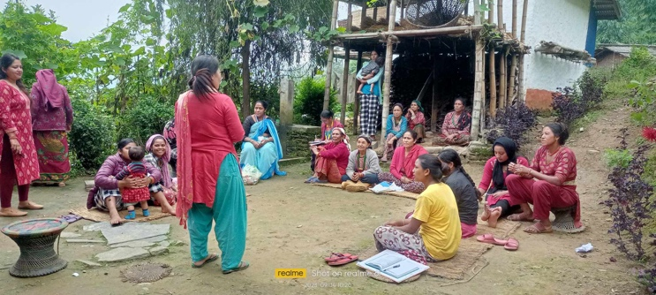Planned 27 events orientations to mothers group about menstrual hygiene and precautions were accomplished during this four month. Orientations meeting were done in each settlements by JSSN field staff. More than 500 women organized in mother groups were participated in menstrual hygiene and precautions orientations. Orientations were so much fruitful to learn about sharing socio-cultural taboos, difficulties in attending into the classroom, taking care and maintaining hygiene and so on.

1. **Training on sanitary pad-making in additional four public schools as per the demands from schools**

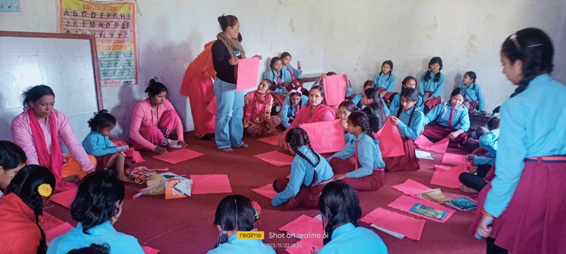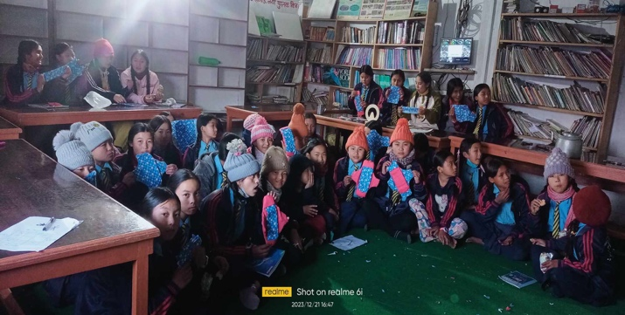Additional sanitary pad making were organized in four more schools as per the demands from the public schools. More than 250 girls from grade 6-12 were participated from each four schools. Adolescent girls learned the technique of reusable and eco-friendly sanitary pad making so that the can manage menstruation with dignity. Girls are able to produce reusable sanitary pads which helping out to reduce school dropout rates of adolescent girls during menstruation and support them to manage their menstruation.

1. **Establishment of resting spaces and appoint teachers as focal person**

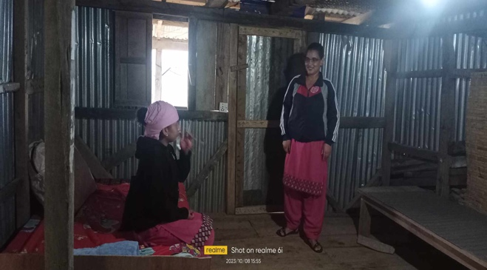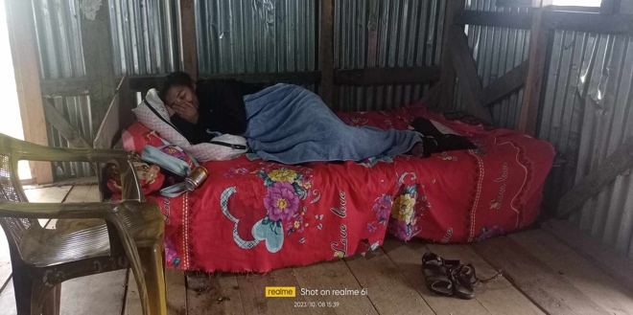A separate resting spaces has been established in each schools. Perceptions regarding the use of resting spaces received female focal teacher is the very exciting. Mrs. Uma Rai, a focal person teacher at Jyoti Secondary School, says ‘resting spaces is very useful for those girls who need some rest during the school’. Each five schools have allocated a separate room for resting spaces and managed the required goods such as bed, pillow, bed cover, safety-pads, dustbin, hot bag, fist aid kit box, electric jug, glass etc. into the rooms. Female focal person teacher plays a lead role in taking care of girl students during the school time in response to the action plan as they prepared.

1. **Create school action plan at the end of training to support girls during menstruation**

Safe and effective menstrual health management is crucial for the good sexual and reproductive health of adolescent girls. When girls are more knowledge about their bodies and fertility, and able to effectively manage their menstrual hygiene. They should be more empowered and better equipped with the information, tools and confidence necessary to manage their long-tern sexual and reproductive health, including family. School is the most component where student spent their time thus, each schools needs to be sincere about the menstrual hygiene. After the completion of menstrual hygiene training and training on safety pad making, each five schools are actively working for the preparation of school’s action plan to ensure the dignified menstruation hygiene. Four schools have prepared their school’s action plan and the rest one school will be making this plan very soon to support girl students during the menstruation.

1. **Follow up on the use and effectiveness of resting spaces**

The analysis of effectiveness of resting spaces is under processing. A meeting was organized in two public schools respectively, Jyoti Secondary School and Kalika Secondary School to know the effectiveness of resting spaces. Girls found more relief once they get a separate resting rooms within the school premises. In a review meeting in Jyoti Secondary School, a students shared her feelings ‘availability of hot water, use of hot bags and general medicines seems most impactful for me while I was suffering so much from stomach paining’. She further argues ‘I found women focal teacher as a mother who provided extra care during the menstruation period’.

1. **Showcase or perform awareness raising activities/programs by student club in communities**

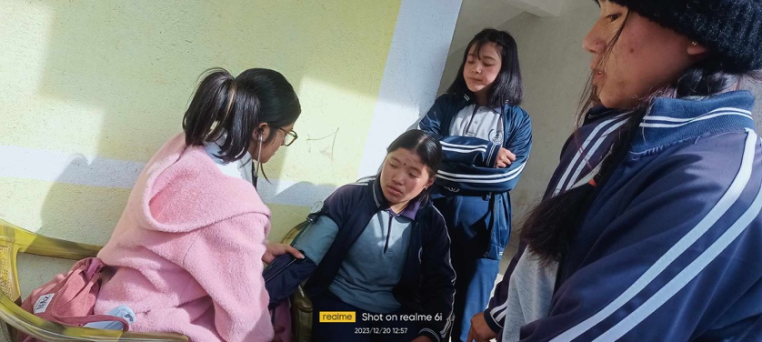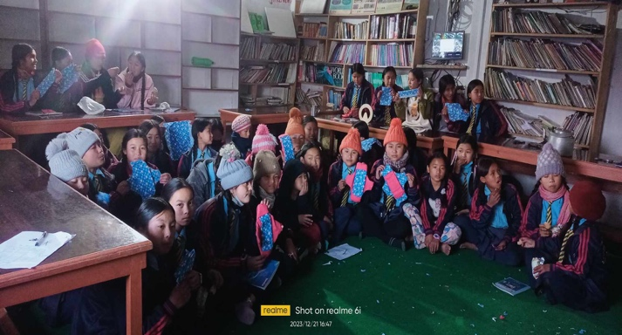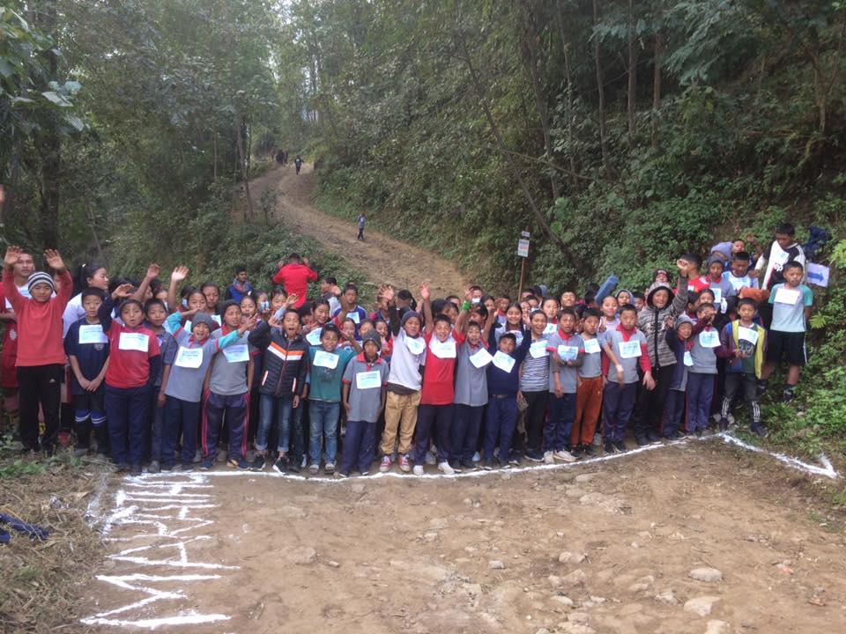Students clubs from the respective schools have accomplished awareness raising activities/programs such as street drama, street marathon and safety-pad demonstration completion. Jyoti Secondary School organized street marathon program on 10th January with the slogan of ‘menstruation with dignity’ and Kalika Secondary School organized a safety-pad demonstration program to internalize the menstruation issue as a biological process and skip out from socio-cultural stigma. Student club from Jalapa Secondary School organized a street drama program with the message of ‘solidarity for dignified menstruation’. Such awareness raising activities contributed to internalize the menstruation issue and its mitigation and measures to overcome from its stigmatized behavior.

1. **Clinical check up of all girls at schools**

Medical staffs from Janasewa Community Hospital were mobilized for the clinical check up of all girls at five public schools. Clinical check up were provided to 405 girls student form five public schools. Medical team provided vital tests (blood pressure, temperature, pulse, respiration, oxygen saturation), vision test, blood sugar random test, and BMI (body mass index) test. The analysis of clinical check up is in progress by medical staffs associated to Janasewa Community Hospital and follow up tests will be done based on the information extracted from the analysis. The clinical check up were carried out as following calendars-

|  |  |  |  |  |
| --- | --- | --- | --- | --- |
| SN | Name of School | Address | Date | # of girls |
| 1 | Sharada Secondary School | Rawabeshi-Haunchur | 18th December 2023 | 87 |
| 2 | Jyoti Secondary School | Diktel Rupakot Majhuwaghi M. | 30th December 2023 | 95 |
| 3 | Jalapa Secondary School | Diktel Rupakot Majhuwaghi M. | 16th December 2023 | 75 |
| 4 | Kalika Secondary School | Diktel Rupakot Majhuwaghi M. | 20th December 2023 | 80 |
| 5 | Saraswoti Secondary School | Diktel Rupakot Majhuwaghi M. | 19th December 2023 | 90 |
|  | **Total** |  |  | **405** |

**Issue and challenges**

* JSSN only has part-time staffs because of financial limitations. Funds available as management cost is insufficient for hiring a full-time staff consequently, the designed activities were delayed in accomplishment.
* JSSN hired an expert for the development of training syllabus for menstruation hygiene and accomplished the training in one event/school however, rest four schools were demanded us the menstruation hygiene and safety pad making training and managed the training from JSSN’s internal source.

**Further planning**

JSSN still has to be accomplished few agreed activities outlined as below. All the rest activities will be done in two weeks.

* Follow up with focal female teachers about impact of training and action plan implementation.
* Complete the use and effectiveness of resting spaces
* Mid or end term meeting with schools based on project experience so far
* Accomplish rest awareness raising activities/programs by student club in communities
* Mid or end term meeting with wards & LG